Task001:

public class Task001 {  
 public static void main(String[] args) {  
 System.*out*.println("Hello.\nHow are you.");  
 }  
}

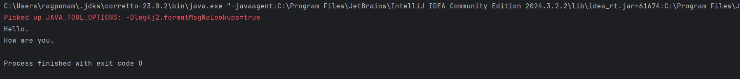

Task002:

public class Task002 {  
  
 static int *x* = 27, *y* = 12;  
 static void add(){  
 int result = *x* + *y*;  
 System.*out*.println(result);  
 }  
  
 public static void main(String[] args) {  
  
 *add*();  
 *add*();  
 *add*();  
 }  
}

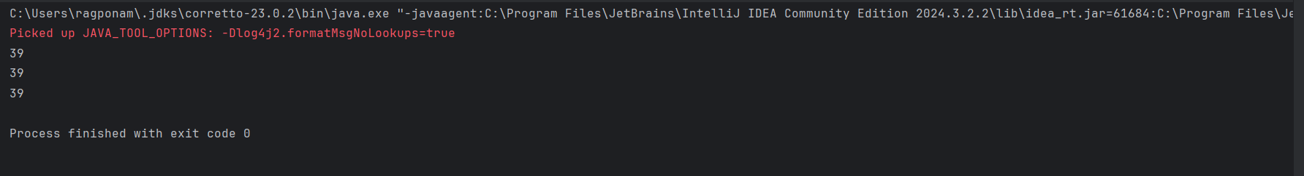

Task003:

import java.util.Scanner;  
  
public class Task003 {  
 public static void main(String[] args) {  
 Scanner scanner = new Scanner(System.*in*);  
 System.*out*.println("Enter the first number: ");  
 int x = scanner.nextInt();  
 System.*out*.println("Enter the second number: ");  
 int y = scanner.nextInt();  
 int result = x+y;  
 System.*out*.println("Sum of two numbers is: "+ result);  
 }  
}

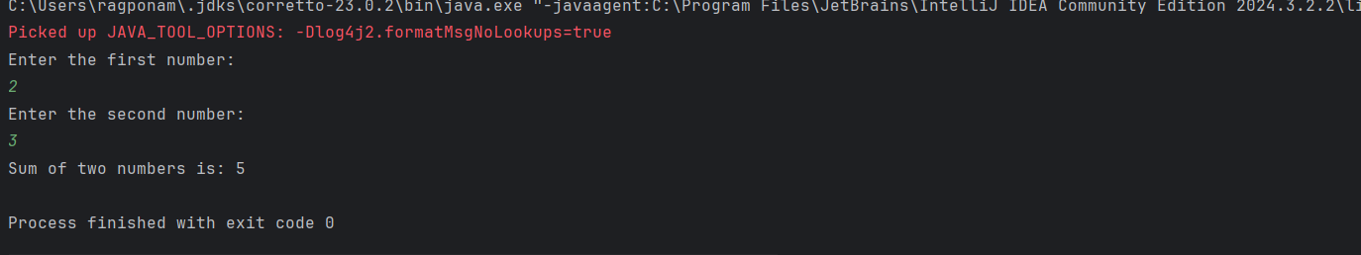

Task004:

public class Task004 {  
 public static void main(String[] args) {  
 int a=2;  
 int b=5;  
 System.*out*.println("Before swap: a="+a+", b="+b);  
 int temp =a;  
 a = b;  
 b = temp;  
 System.*out*.println("After swap: a="+a+", b="+b);  
  
 }  
}

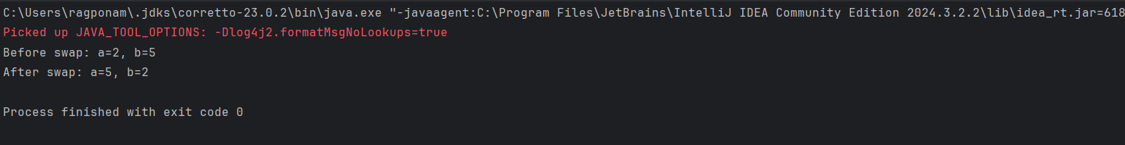

Task005:

public class Task005 {  
 static int *a* =8;  
 static int *b*=4;  
 static void add(){  
 int sum = *a*+*b*;  
 System.*out*.println(sum);  
 }  
 static void diff(){  
 int diff = *a*-*b*;  
 System.*out*.println(diff);  
 }  
 static void prod(){  
 int prod = *a*\**b*;  
 System.*out*.println(prod);  
 }  
 static void div(){  
 int div = *a*/*b*;  
 System.*out*.println(div);  
 }  
  
 public static void main(String[] args) {  
 *add*();  
 *diff*();  
 *prod*();  
 *div*();  
  
 }  
}

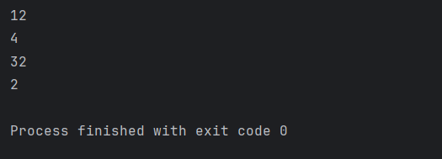

Task006:

public class Task006 {  
 public static void main(String[] args) {  
 int a = 10;  
 int b = 5;  
  
 String result = (a > b) ? "a is greater" : "b is greater or equal";  
 System.*out*.println(result);  
 }  
}

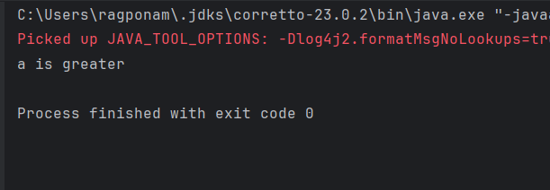

Task 007:

import java.util.Scanner;  
  
public class Task007 {  
 public static void main(String[] args) {  
 Scanner scanner = new Scanner(System.*in*);  
 System.*out*.print("Please enter the Id: ");  
 String Id = scanner.nextLine();  
 System.*out*.print("Please enter the password: ");  
 String pwd = scanner.nextLine();  
 System.*out*.println("Id: "+Id +"\npwd: "+pwd);  
  
 }  
}

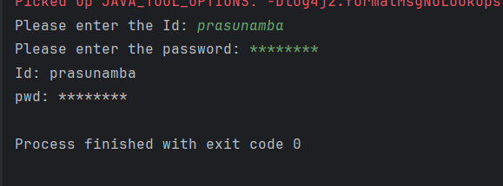

Task008:

class Customer{  
 void accept(){  
 System.*out*.println("Accept customer called");  
 }  
 void display(){  
 System.*out*.println("Display customer called");  
 }  
 }  
 public class Task008 {  
 public static void main(String[] args) {  
 Customer cObj = new Customer();  
 cObj.accept();  
 cObj.display();  
 }  
}

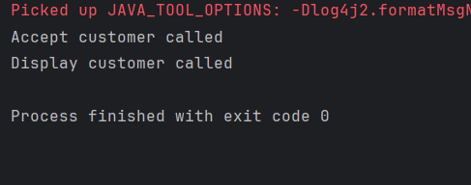

Task009:

import java.util.Scanner;  
  
public class Task009 {  
 public static void main(String[] args) {  
 Scanner scanner = new Scanner(System.*in*);  
 System.*out*.print("Enter the first number x: ");  
 int x = scanner.nextInt();  
 System.*out*.print("Enter the second number y: ");  
 int y = scanner.nextInt();  
 if (x>y){  
 System.*out*.println(x+ " is greater");  
 }  
 else {  
 System.*out*.println(y +" is greater.");  
 }  
  
 }  
}

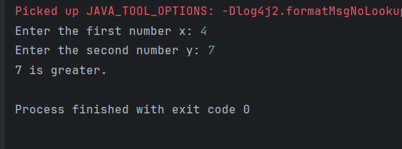

Task010:

import java.util.Scanner;  
  
public class Task010 {  
 public static void main(String[] args) {  
 Scanner scanner = new Scanner(System.*in*);  
 System.*out*.print("Enter the first number x: ");  
 int x = scanner.nextInt();  
 System.*out*.print("Enter the second number y: ");  
 int y = scanner.nextInt();  
 System.*out*.print("Enter the third number z: ");  
 int z = scanner.nextInt();  
  
 if (x>y && x>z){  
 System.*out*.println(x+ " is greater.");  
 } else if (y>z && y>x ) {  
 System.*out*.println(y+ " is greater.");  
 }  
 else {  
 System.*out*.println(z + " is greater.");  
 }  
 scanner.close();  
 }  
 }

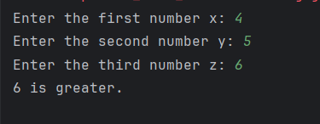

Task011:

import java.util.Scanner;  
  
public class Task011 {  
 public static void main(String[] args) {  
 Scanner scanner = new Scanner(System.*in*);  
 System.*out*.println("Enter a number between 1-7 with Sunday starting from 1 till Saturday ending at 7: ");  
 int dayNum = scanner.nextInt();  
 switch (dayNum){  
 case 1:  
 System.*out*.println("Sunday");  
 break;  
 case 2:  
 System.*out*.println("Monday");  
 break;  
 case 3:  
 System.*out*.println("Tuesday");  
 break;  
 case 4:  
 System.*out*.println("Wednesday");  
 break;  
 case 5:  
 System.*out*.println("Thursday");  
 break;  
 case 6:  
 System.*out*.println("Friday");  
 break;  
 case 7:  
 System.*out*.println("Saturday");  
 default:  
 System.*out*.println("Please enter any integer in range 1-7");  
 }  
 }  
}

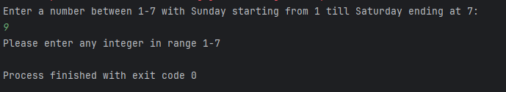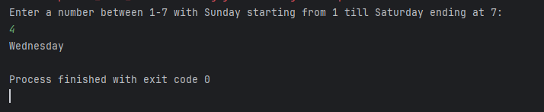

Task012:

import java.util.Objects;  
import java.util.Scanner;  
  
public class Task012 {  
  
 private static final String *CORRECT_LOGIN_ID* = "raghu";  
 private static final String *CORRECT_PASSWORD* = "password";  
  
 public static void validateWithWhileLoop(Scanner scanner) {  
 System.*out*.println("--- Starting Login Validation with WHILE Loop ---");  
 String enteredLoginId;  
 String enteredPassword;  
 int attemptCount = 0;  
  
 enteredLoginId = "";  
 enteredPassword = "";  
  
 while (!Objects.*equals*(enteredLoginId, *CORRECT_LOGIN_ID*) || !Objects.*equals*(enteredPassword, *CORRECT_PASSWORD*)) {  
 attemptCount++;  
  
 System.*out*.println("Attempt #" + attemptCount + ":");  
 System.*out*.print("Enter your Login ID: ");  
 enteredLoginId = scanner.nextLine();  
  
 System.*out*.print("Enter your Password: ");  
 enteredPassword = scanner.nextLine();  
  
 if (!Objects.*equals*(enteredLoginId, *CORRECT_LOGIN_ID*) || !Objects.*equals*(enteredPassword, *CORRECT_PASSWORD*)) {  
 System.*out*.println("Invalid Login ID or Password. Please try again.\n");  
 }  
 }  
  
 System.*out*.println("\nLogin successful using WHILE loop!");  
 System.*out*.println("You logged in after " + attemptCount + " attempt(s).\n");  
 }  
  
 public static void validateWithDoWhileLoop(Scanner scanner) {  
 System.*out*.println("--- Starting Login Validation with DO-WHILE Loop ---");  
 String enteredLoginId;  
 String enteredPassword;  
 int attemptCount = 0;  
  
 do {  
 attemptCount++;  
  
 System.*out*.println("Attempt #" + attemptCount + ":");  
 System.*out*.print("Enter your Login ID: ");  
 enteredLoginId = scanner.nextLine();  
  
 System.*out*.print("Enter your Password: ");  
 enteredPassword = scanner.nextLine();  
  
 if (!Objects.*equals*(enteredLoginId, *CORRECT_LOGIN_ID*) || !Objects.*equals*(enteredPassword, *CORRECT_PASSWORD*)) {  
 System.*out*.println("Invalid Login ID or Password. Please try again.\n");  
 }  
  
 } while (!Objects.*equals*(enteredLoginId, *CORRECT_LOGIN_ID*) || !Objects.*equals*(enteredPassword, *CORRECT_PASSWORD*));  
  
 System.*out*.println("Login successful using DO-WHILE loop!");  
 System.*out*.println("You logged in after " + attemptCount + " attempt(s).\n");  
 }  
  
 public static void main(String[] args) {  
 Scanner scanner = new Scanner(System.*in*);  
  
 *validateWithWhileLoop*(scanner);  
  
 *validateWithDoWhileLoop*(scanner);  
  
 scanner.close();  
 System.*out*.println("Program finished.");  
 }  
}

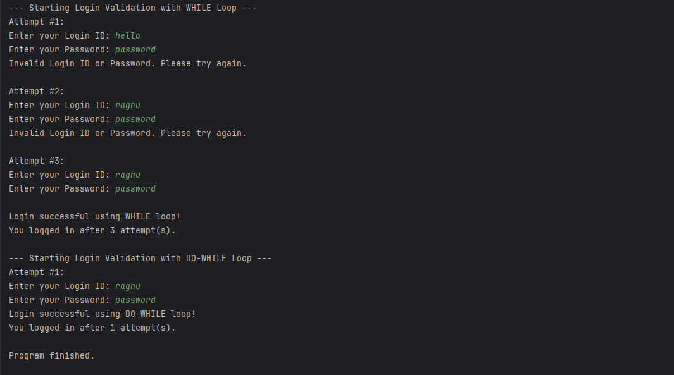

Task013:

public class Task013 {  
 public static void main(String[] args) {  
 for (int i=10; i>0;i--){  
 if (i ==5 || i==7){  
 continue;  
 }  
 System.*out*.println(i);  
 }  
 }  
}

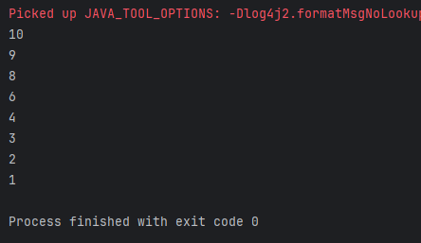

Task014:

package Arrays;  
  
public class Task014 {  
  
 public static void main(String[] args) {  
 // *TODO Auto-generated method stub* char[] arr = {'a','e','i','o','u'};  
 System.*out*.println(arr);  
 String[] names = {"Meena", "Tina", "Veena", "heena"};  
 System.*out*.println(names[0]);  
 names[1]= "Reena";  
 System.*out*.println(names[1]);  
 System.*out*.println(names.length);  
 System.*out*.println(names[4]);  
 System.*out*.println(arr[5]);  
 System.*out*.println(arr[-1]);  
   
 }  
 //Exception in thread "main" java.lang.ArrayIndexOutOfBoundsException  
  
 }

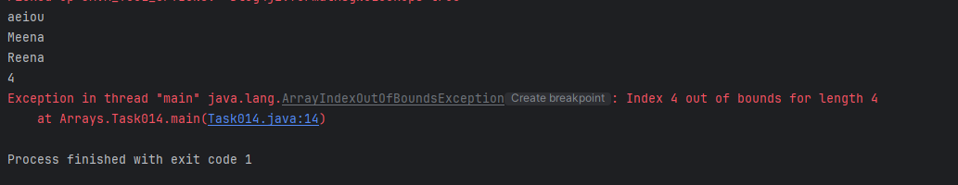

Task015:

public class Task015 {  
  
 public static void main(String[] args) {  
   
 String str1 = "Java Strings "; // string Literal  
 String str2 = new String(str1); // obj of the string - new keyword  
 String str3 = new String("are easy to learn ");  
 char ch[] = {'S', 't', 'r' ,'i', 'n', 'g'};  
 String str4 = new String(ch);  
 System.*out*.println(str1 + "\n" + str2 + "\n" +str3 + "\n" +str4);  
  
 }  
  
}

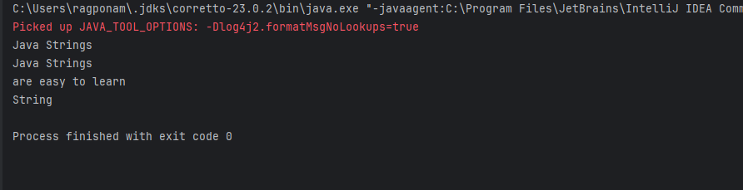

Task016_color:

package Enumerations;  
enum color{  
 *red*, *blue*, *green*, *yellow*}  
public class Task016_color {  
  
 public static void main(String[] args) {  
 color c1 = color.*red*;  
 System.*out*.println(c1);  
 }  
}

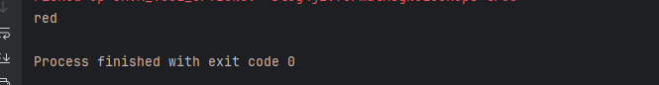

Task016_day:

package Enumerations;  
enum Weekdays{  
 *Sunday* , *Monday* , *Tuesday*}  
public class Task016_day {  
  
 public static void main(String[] args) {  
 Weekdays c1 = Weekdays.*Tuesday*;  
 System.*out*.println(c1);  
 }  
}

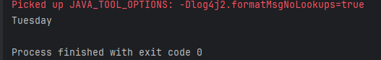

Task017:

public class Person {  
 private String name;  
  
 // Getter  
 public String getName() {  
 return name;  
 }  
  
 // Setter  
 public void setName(String newName) {  
 this.name = newName;  
 }  
}

public class Task017{  
 public static void main(String[] args) {  
 Person myObj = new Person();  
 myObj.name = "John";  
 System.*out*.println(myObj.name);  
 }  
}

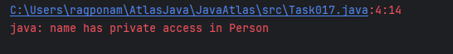

As mentioned in the error, name is a private variable and cannot be accessed out of that particular class i.e., class person. Instead getName/ setName (getter/setter) can be used to modify or access name in Class Task017.

Task018:

public class Task018 {  
 public static void main(String[] args) {  
 Person myObj = new Person();  
 myObj.setName("John");  
 System.*out*.println(myObj.getName());  
 }  
}

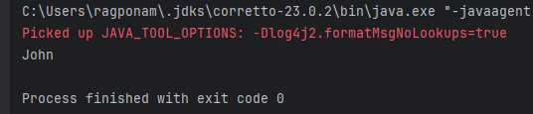

Task020:

public class Task020 {  
  
 public static void main(String[] args) {  
 char[] name = {'R', 'a', 'g', 'h', 'u'};  
  
 // Corrected line: Convert the char array to a String before printing.  
 System.*out*.println("My name as a character array: " + new String(name));  
  
 int n = name.length;  
  
 System.*out*.println("There are " + n + " letters in my name.");  
  
 System.*out*.print("\nEach letter in my name: ");  
 for (int i = 0; i < n; i++) {  
 System.*out*.print(name[i] + " ");  
 }  
 System.*out*.println();  
 }  
}

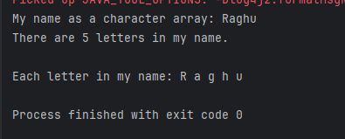

Task019:

public class Task019 {  
  
 public static void main(String[] args) {  
   
  
  
  
 for (Element element : Element.*values*()) {  
  
 System.*out*.printf("Symbol: %s, Label: %s, Atomic Number: %d, Atomic Weight: %.4f%n",  
 element.name(),  
 element.label,  
 element.atomicNumber,  
 element.atomicWeight);  
 }  
  
 System.*out*.println("\n--- Demonstrating Element lookup methods (from Task016_1) ---");  
  
  
 Element carbon = Element.*valueOfLabel*("Carbon");  
 if (carbon != null) {  
 System.*out*.printf("Lookup by Label 'Carbon': Found %s (Atomic Number: %d)%n",  
 carbon.name(), carbon.atomicNumber);  
 } else {  
 System.*out*.println("Element 'Carbon' not found by label.");  
 }  
  
  
 Element nitrogen = Element.*valueOfAtomicNumber*(7);  
 if (nitrogen != null) {  
 System.*out*.printf("Lookup by Atomic Number 7: Found %s (Label: %s)%n",  
 nitrogen.name(), nitrogen.label);  
 } else {  
 System.*out*.println("Element with Atomic Number 7 not found.");  
 }  
  
 Element nonExistent = Element.*valueOfLabel*("ImaginaryElement");  
 if (nonExistent == null) {  
 System.*out*.println("Lookup for 'ImaginaryElement': Result is null (as expected).");  
 }  
 }  
}

